**Note: For the Equipment page, couldn’t find the feasibility in xamarin forms for Equipment page into a pop up page and also use radio buttion. So we have developed Equipment page in normal page and have used toggle in place of radio button.**

1.

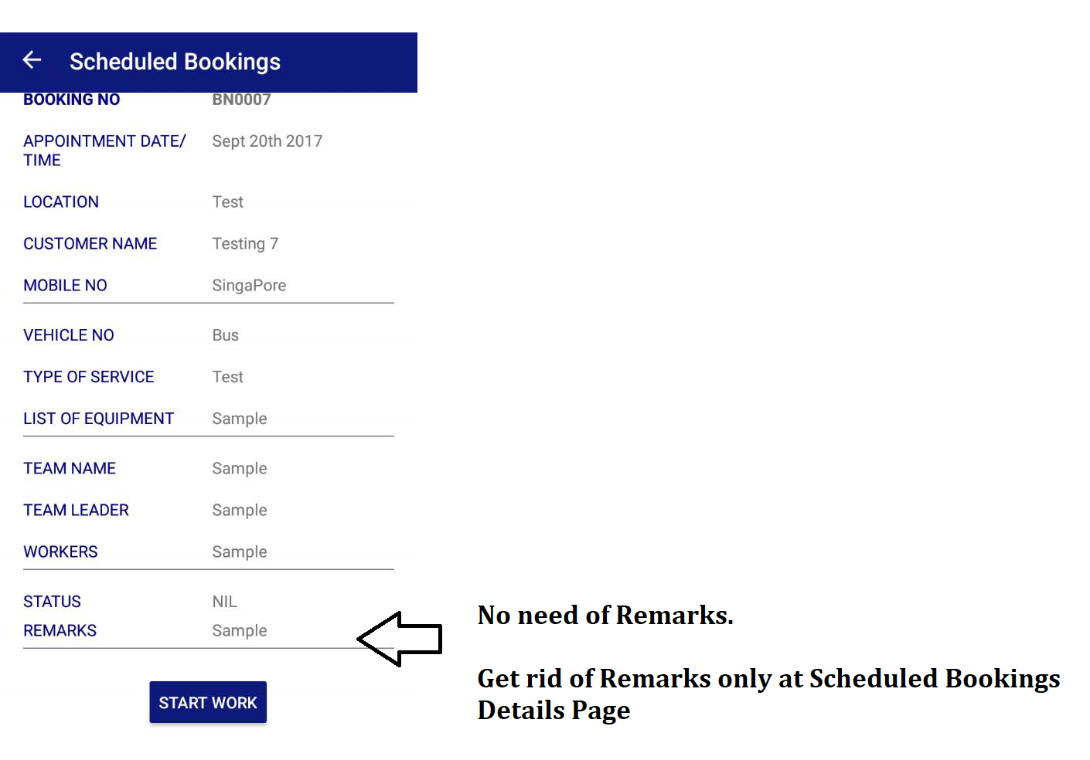

2.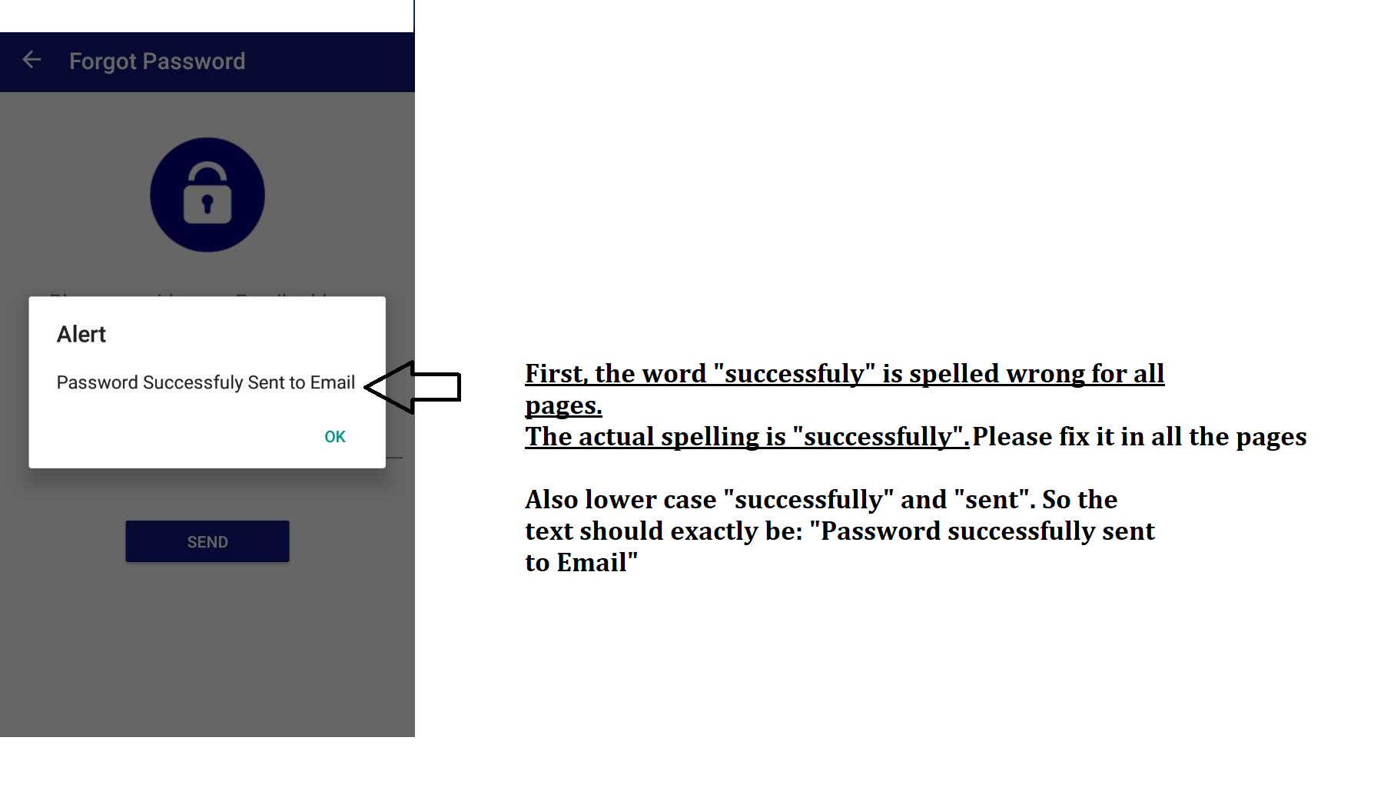

3.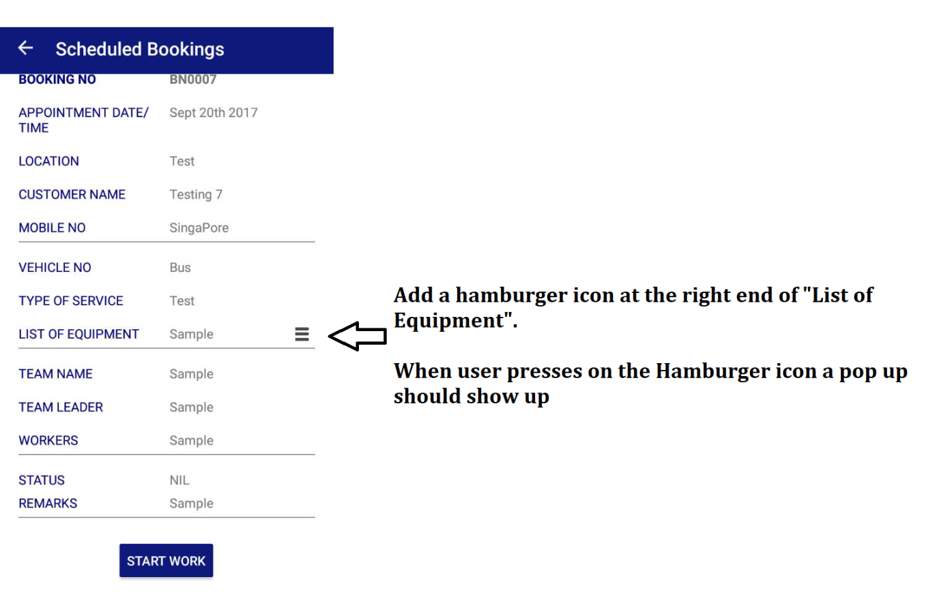

**Title is: Check for Equipment**

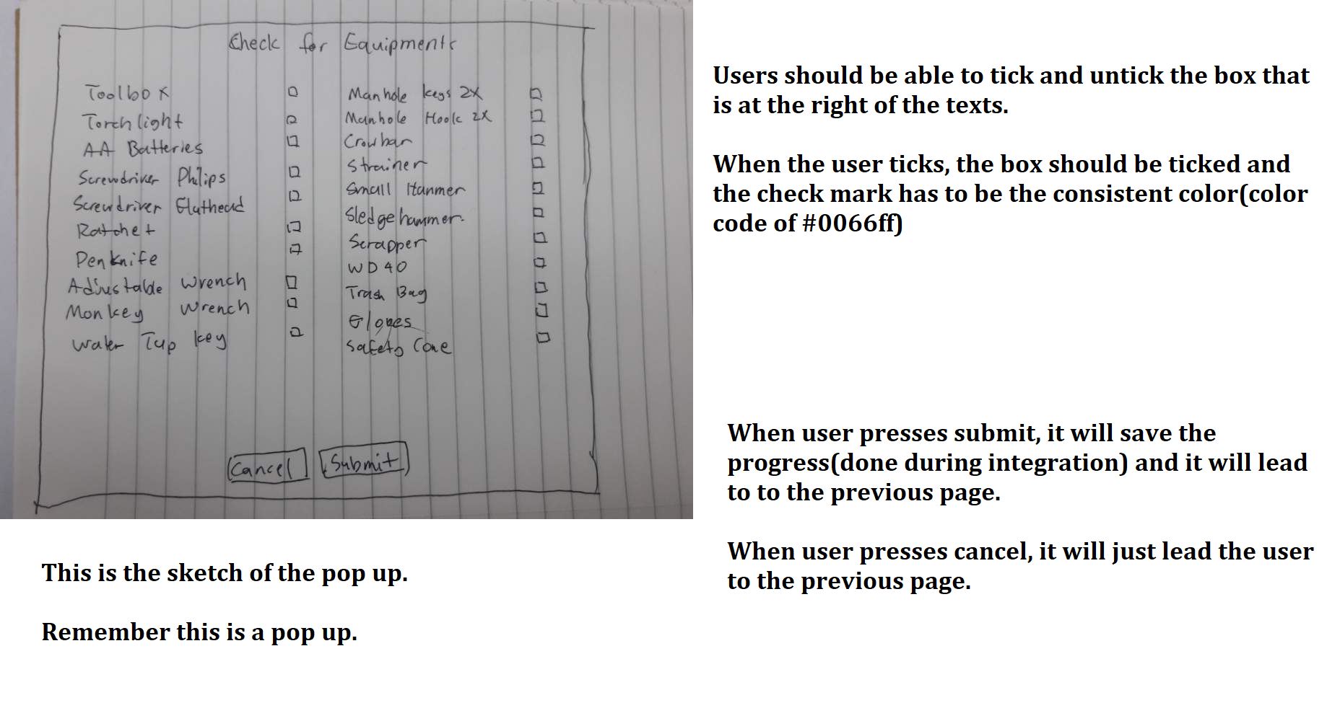

These are the words that are in the list:

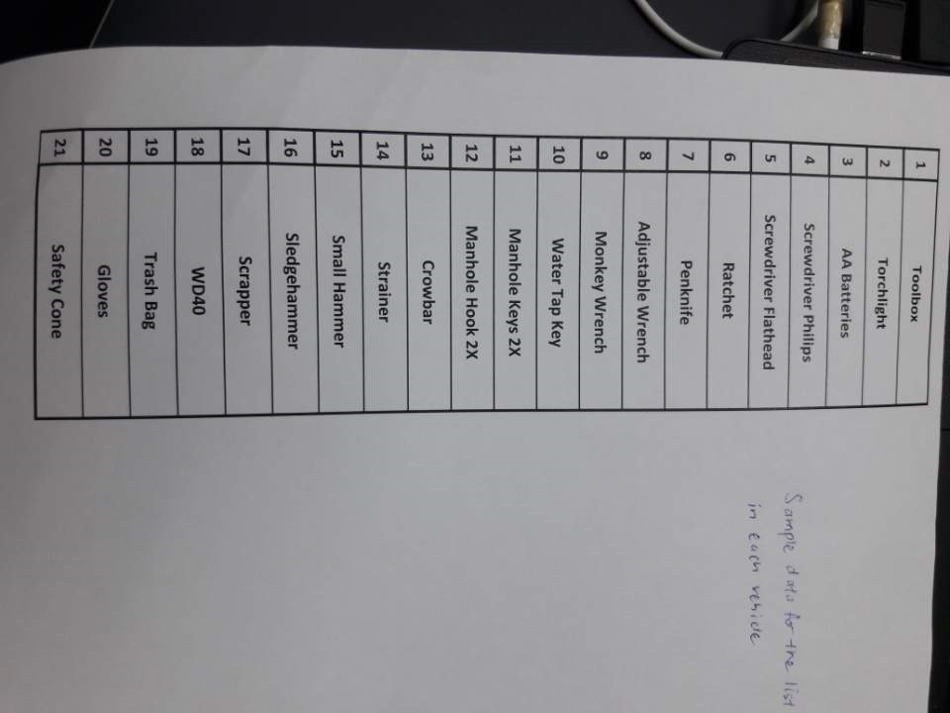

Hamburger Icon:

